Darlington Point Public School
Tomorrow is ours

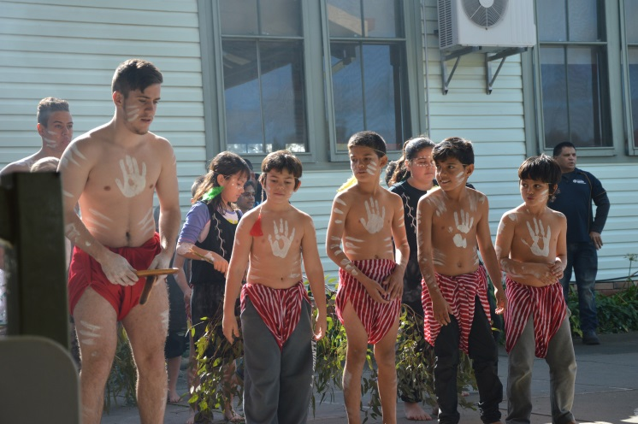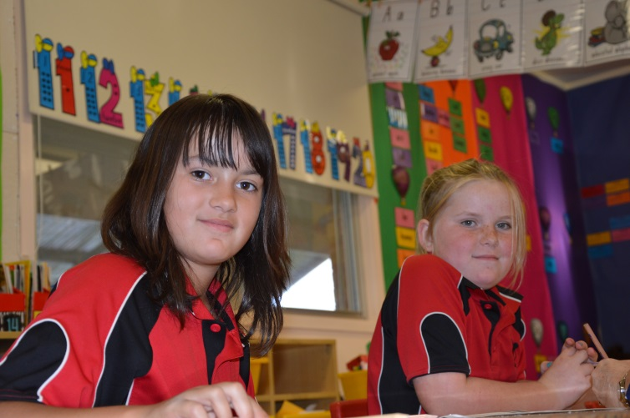

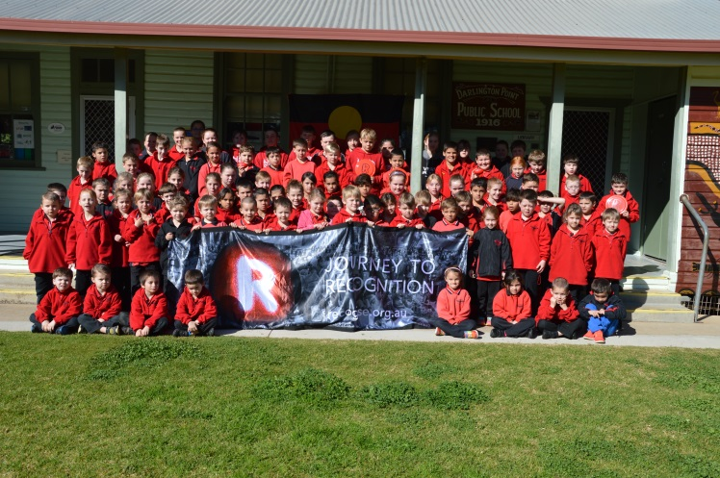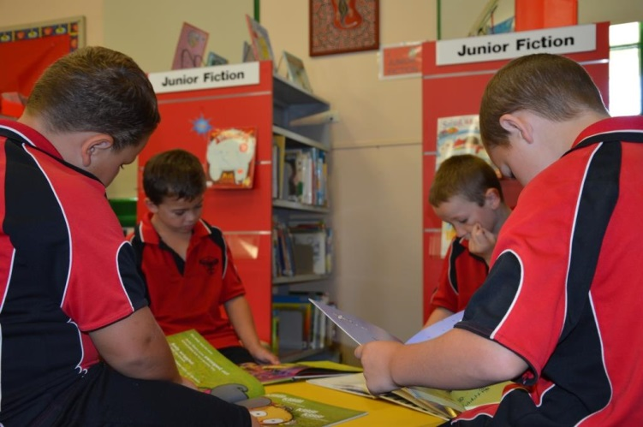

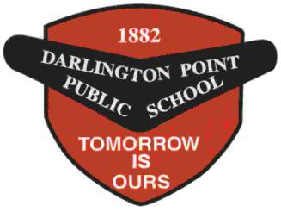School Prospectus

Darlington Point Public School

School Details
Address: | 14-22 Hay Road Darlington Point
Telephone: | (02) 69684114
Fax: | (02) 69684269
Email: | darlingtpt-p.school@det.nsw.edu.au
Website: | www.darlingtpt-p.schools.nsw.edu.au
Principal: | Mr. Richard Busby
Office Hours: | 9.00am –– 3.25pm
Bell Times:
8:50am | Supervision commences
9:15am | Students assemble
9:15-11:15am | Literacy
11:15-11:35am | Recess
11:35-12:40am | Numeracy
12:40pm –– 1:10pm | Fitness/Handwriting
1:10pm –– 1:25pm | Eating
1:25pm –– 1:42pm | 1st Half Lunch
1:40pm –– 2:00pm | 2nd Half Lunch
2:00pm – 3:15pm | Afternoon
3:15pm | School day ends

Welcome to Darlington Point Public School

Strives for quality teaching and learning by working together for children

On behalf of the staff, students and parents of Darlington Point Public School, I welcome you and your child to our school. Darlington Point provides education from Kindergarten to Year 6. Your child is our main concern and we want to work together to ensure the child's best interests are met.

We invite you to become acquainted with all aspects of our school's programs because we strive for quality teaching and learning with a caring and competent staff. In pursuing this achievement we believe:

- In implementing a balanced curriculum that caters for your child’s academic, social, cultural and physical development so as to ensure individual satisfaction, success and confidence;
- All students will know what is expected of them within a caring environment that fosters responsibility, respect, co-operation, trust, acceptance, achievement and other traditional values;
- Everyone will share in the school’s beliefs and work together for improvement;

- That staff will be supportive and continually building upon their knowledge and expertise of teaching;

- Positive home/school relations are vital for the educational well-being of our students.

You are encouraged to join our programs and are encouraged to participate directly in your child's education and welfare. This may be done by attending or supporting our parent organisations, ensuring there is communication with the staff through regular parent/teacher interviews and meetings and by involving and assisting in school based programs.

The success of the policies and programs involves the school, parents and the community:

Working together for children.

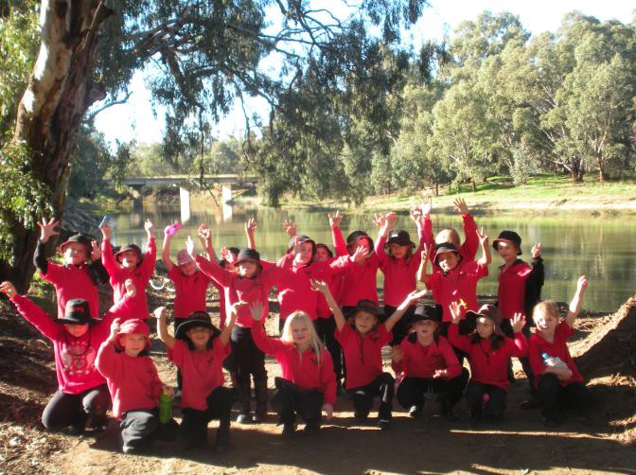Richard Busby Principal

School Information

ASSEMBLY

Assembly is held every Friday at 9.25am in the school hall. It is at this time that announcements concerning the week’’s activities are made. Assembly is conducted by the student leaders and it is at this time that merit awards and special awards to students based on academic or extra-curricular performance and effort are presented. Parents are welcome to attend.

ATTENDANCE

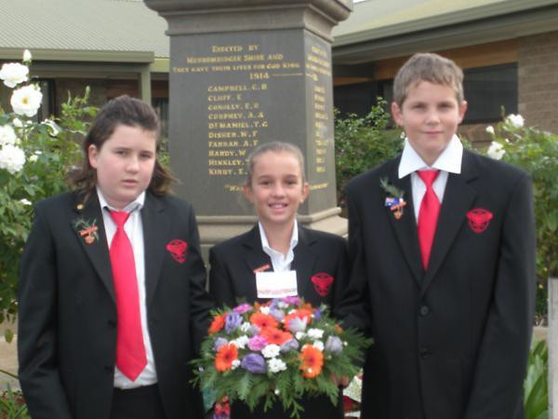Government legislation requires students between the ages of six and fifteen to be enrolled at a government or registered non-government school and to attend school on each day that instruction is provided. It is the duty of the parent or care-provider of these students, under the Education Reform Act 1990, to ensure that these obligations are fulfilled. The Act specifies that absences must be explained within 2 days of the occurrence. Notes explaining the absence have to be sent to the class teacher on the day that the child returns. Alternatively, a verbal message (eg. phone call) can be made to the school to explain a particular absence. Unsatisfactory or unexplained absence is reported to the Home School Liaison Officer. If for any reason a child has to leave the school grounds at any time a note fully stating the reason has to be received before permission can be
granted. If you have planned a family holiday or event please let the school know before leaving.

ACCIDENTS AND SICKNESS

Emergency contact numbers are filled in at the time of enrolment. This enables the school to contact parents or the nominated local person in case of sickness or accident. It is important that you inform the school of changes in place of work, phone numbers and addresses so that records can be kept up to date.

Children becoming ill should report to their class teacher and if too ill to remain at school every effort will be made to contact the parents or the emergency contact number.

If your child appears ill in the morning before school you are advised to keep them at home.

Injured children should always report their injury to the teacher on duty in the play- ground. Minor injuries will be treated by our school assistant (Mrs Mc Corkelle). In the case of more serious matters every effort will be made to contact the parents or the emergency contact number. If these numbers cannot be reached medical attention, if required, will be sought.

ASTHMA

Our school is rated an Asthma Friendly School. This means that all staff have undergone training in asthma education. If your child suffers from asthma then we ask parents to complete an asthma management plan in consultation with your GP.

All children should be trained in the use of their puffer, etc and carry it with them at all times.

BANKING

The student banking scheme is provided by the Commonwealth Bank and is conducted each Friday at 9.00am – 9.30am.

BEHAVIOUR MANAGEMENT SYSTEM

Our school behaviour management system is based on our three core values:

Core values Respect Responsibility
Cooperation

These core values provide a framework for the school behaviour management system and explicit school rules.

School Rules

School rules have been broken up into specific requirements for different areas of the school. All school rules relate back to our three core values.

Playground rules

  - Keep hands and feet to yourself
  - Be polite
  - No rough play
  - Wear your hat and shoes
  - Be in the safe play areas

Assembly

- Be on time
- Be in the right place
- Be quiet

Canteen

- Wait your turn sensibly
- Use your manners
- After buying, return to the playground
Classroom

At the start of each year class teachers will develop their classroom rules with the students. These rules will:

  - Be as positively phrased as possible
  - Consist of 3 -5 statements
  - Be devised and negotiated together as a whole class
  - Be distributed to parents

BIKE RIDING

Darlington Point Public School follows the guidelines set down by the R.T.A. which state that children under 10 years of age are not physically mature to ride safely on roads, unsupervised. Bike riding to school under this age is not encouraged. Children who do ride to school are expected to know and obey the rule for bike riders on the road.

No child is to ride to school unless they are wearing a helmet.
For safety reasons bikes are not to be ridden in the school grounds.

BOOK CLUB – Scholastic

Throughout the year, children are given pamphlets on which various books are advertised for purchase at special prices. If you would like your child to order a book, the money and order form are returned to school in an envelope marked clearly with name and class.

BUS TRAVEL

All students in Kindergarten to Year 2 are eligible for free bus travel. Students in Years 3-6 must live at least 1.6 km from school to be eligible. An application travel form must be filled out by parent/carer for every student travelling by bus. This form is available from the school office.

Whilst on the bus the behaviour of all children is the responsibility of parents and the bus proprietors. Unacceptable

behaviour may result in a student being unable to use the bus service.

At the end of each school day, students travelling on buses are supervised by the teachers on duty, until they enter the bus.

CANTEEN

The school canteen operates every Monday and Friday at recess and lunchtime. Parents wishing to help in the canteen should contact the office. Lunch orders should be written on the outside of a brown paper bag with child’s name and class marked clearly and money placed inside.

All orders should be made before 9.25am.

CAR PARKING

Parents are advised to observe the parking signs near the school. It is not only illegal but dangerous to disregard these signs. Police enforce these regulations from time to time.

School Zones operate on all of the streets surrounding the school. The speed limit is 40km.

CHILDREN LEAVING SCHOOL GROUNDS

In order to safeguard our children, no child will be allowed to leave the school without the permission of the principal. Should the need arise e.g. medical, dental, family matters, etc., a note explaining the reason must be given to your child's teacher. If picking up your child in an emergency please call at the office before going to the classroom.

COMMON CHILDHOOD DISEASES

Chicken Pox
Time from exposure to illness
2 to 3 weeks. Symptoms:
Slight fever, runny nose, and a rash that begins as raised pink spots that blister and scab. Can be more severe in pregnant women and newborns.
Do I need to keep my child home?
Yes, for 5 days after the rash first appears and until the blisters have all scabbed over.
How can I help prevent spread? Immunisation is available for children over 12 months old. It is recommended for people over 12 years who are not immune.

Conjunctivitis
Time from exposure to illness 1-3 days.
Symptoms:
The eye feels scratchy, is red and may water. Lids may stick together on waking. Do I need to keep my child home?
Yes, while there is discharge from the eye. How can I help prevent spread?
Careful hand washing; avoid sharing towels.
Antibiotics may be needed.

Gastroenteritis
Time from exposure to illness
Depends on the cause: several hours to several days.
Symptoms
A combination of frequent loose or watery stools, vomiting, fever, stomach cramps, headaches.
Do I need to keep my child home? Yes, at least for 24 hours after diarrhea stops.
How can I help prevent spread?
Careful hand washing with soap and water after using the toilet or handling nappies and before touching food.

German measles (Rubella) Time from exposure to illness 2 to 3 weeks.
Symptoms
Often mild or no symptoms, mild fever, runny nose, swollen nodes, pink blotchy

rash that lasts a short time. Can cause birth defects if pregnant women are infected.
Do I need to keep my child home? Yes, for at least 4 days after the rash appears.
How can I help prevent spread? Immunisation (MMR) at 12 months and 4 years of age.

Glandular fever
Time from exposure to illness 4 to 6 weeks.
Symptoms
Fever, headache, sore throat, tiredness, swollen nodes.
Do I need to keep my child home? No, unless sick.
How can I help prevent spread? Careful hand washing. Avoid sharing drinks, food and utensils and kissing.

Hand, foot and mouth disease
Time from exposure to illness 3 to 7 days.
Symptoms
Mild illness, perhaps with a fever, blisters around the mouth, on the hands and feet, and perhaps the nappy area.
Do I need to keep my child home? Yes, until the blisters have dried. How can I help prevent spread?
Careful hand washing especially after wiping noses, using the toilet and changing nappies.

Head Lice
Time from infestation to eggs hatching Usually 5 to 7 days.
Symptoms
Itchy scalp, white specks stuck near the base of the hairs, lice may be found on the scalp.
Do I need to keep my child home? No, as long as headlice treatment is ongoing.
How can I help prevent spread? Family, friends and classroom contacts should be examined and treated if
infested.

Hepatitis A
Time from exposure to illness About 2 to 6 weeks.
Symptoms
Often none in small children; sudden fever, loss of appetite, nausea, vomiting, jaundice (yellowing of skin and eyes), dark urine, pale stools.
Do I need to keep my child home?
Yes, for 2 weeks after first symptoms or 1 week after onset of jaundice.
How can I help prevent spread?
Careful hand washing; close contacts may need to have an Injection of immunoglobulin; immunisation recommended for some people.

Impetigo (school sores) Time from exposure to illness 1 to 3 days.
Symptoms
Small red spots change into blisters that fill with pus and become crusted; usually on the face, hands or scalp.
Do I need to keep my child home?
Yes, until treatment starts. Sores should be covered with a watertight dressing How can I help prevent spread?
Careful hand washing.

Measles
Time from exposure to illness:
About 10 to 12 days until first symptoms, and 14 days until the rash develops.
Symptoms
Fever, tiredness, runny nose, cough and sore red eyes for a few days followed by a red blotchy rash that starts on the face and spreads down the body and lasts 4 to 7 days.
Do I need to keep my child home? Yes, for at least 4 days after the rash appears.
How can I help prevent spread? Immunisation (MMR) at 12 months and 4 years. Contacts who are not immune should not attend school or work for 14 days.

Meningococcal disease Time from exposure to illness 2 to 10 days.
Symptoms
Sudden onset of fever and a combination of headache, neck stiffness, nausea, vomiting, drowsiness and rash.
Do I need to keep my child home? Seek medical help immediately. Patient will need hospital treatment.
How can I help prevent spread? Avoid sharing drinks. Close contacts should see their doctor urgently if
symptoms develop, and may need to have a special antibiotic.

Mumps
Time from exposure to illness 14 to 25 days.
Symptoms
Fever, swollen and tender glands around the jaw.
Do I need to keep my child home? Yes, for 9 days after onset of swelling. How can I help prevent spread?
Immunisation (MMR) at 12 months and 4 years of age.

Ringworm
Time from exposure to illness Varies (may be several days). Symptoms
Small scaly patch on the skin surrounded by a pink ring.
Do I need to keep my child home? Yes, until the day after treatment has begun.
How can I help prevent spread? Careful hand washing.

Scabies
Time from exposure to illness New infections: 2 to 6 weeks
Reinfections: 1 to 4 days. Symptoms
Itchy skin, worse at night. Worse around wrists, armpits, buttocks, groin and between fingers and toes.
Do I need to keep my child home? Yes, until the day after treatment has begun.
How can I help prevent spread? Close contacts should be examined for infestation and treated if necessary. Wash linen, towels and clothing worn in the past 2 days in hot water and detergent.

Scarlet fever
Time from exposure to illness 1 to 3 days.
Symptoms
Sudden onset sore throat, high fever and vomiting, followed by a rash in 12 to 36 hours.
Do I need to keep my child home?
Yes, until at least 24 hours of treatment has begun and the child is feeling better. How can I help prevent spread?
Careful hand washing. Sick contacts should see their doctor.

Whooping Cough (pertussis) Time from exposure to illness 7 to 20 days.
Symptoms
Starts with runny nose, followed by persistent cough that comes in bouts. Bouts may be followed by vomiting and a whooping sound as the child gasps for air. Do I need to keep my child home?
Yes, until the child has taken the first 5 days of a special antibiotic.
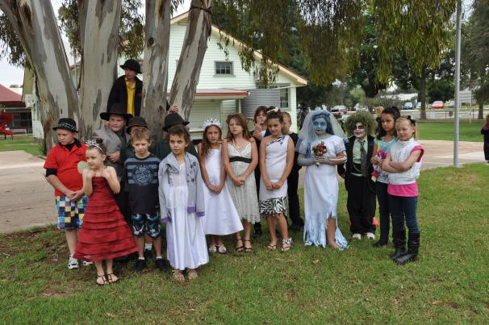How can I help prevent spread? Immunisation at 2, 4, 6, and 18 months and 4 years of age. A special antibiotic can be given for the patient and close contacts. Unimmunised contacts may be excluded from child care until they have taken the first 5 days of a special antibiotic

CRUNCH & SIP

Crunch&Sip is a set break for students to eat fruit or salad vegetables and drink water in the classroom. Darlington Point Public School has introduced Crunch&Sip to support students to establish healthy eating habits while at school.

All students and teachers should enjoy a Crunch&Sip break to eat fruit and vegetables and drink water in the classroom every day.

The objectives of Crunch&Sip are to:

- Increase awareness of the importance of eating fruit and vegetables and drinking water every day.
- Enable students, teachers and staff to eat fruit or vegetables during an allocated Crunch&Sip break in the classroom.
- Encourage students, teachers and staff to drink water regularly throughout the day, including during sports, excursions and camps.
- Encourage parents to provide students with fruit and vegetables every day.
- Develop strategies to help students who don’t have regular access to fruit and vegetables.
- Reinforce the healthy eating messages taught during Crunch&Sip break with nutrition education taught during PDHPE lessons.

CURRICULUM

School-based policies, developed by the staff, are designed to meet the particular needs of the children at Darlington Point Public School.
While a strong emphasis is placed on the teaching of the basic skills we attempt to provide a balanced program which allows for the total development of the child.
The curriculum is divided into six Key Learning Areas (K.L.A.'s):

  - English
  - Mathematics
  - Science & Technology
  - Human Society & Its Environment
  - Creative & Practical Arts
  - Personal Development, Health and Physical Education

Programs are designed which cater for individual differences in children. This means children are able to proceed at their own levels and rates of development because there is provision for helping the less able child while extending the more capable learner.

English
In English, students learn to read, write, talk and listen. They learn about the English language and literature, how language varies according to context and how to communicate to a range of audiences for different purposes. Your child will learn to read for information and pleasure while also learning about poetry, novels and plays. They will gain a sound grasp of language structures, punctuation, spelling and grammar.

Mathematics
Mathematics develops students’ thinking, understanding, competence and confidence with numbers, shapes and measurement. Students learn to add, subtract, divide and multiply whole numbers, fractions and decimals. They learn to measure time and calculate with money. Your child will learn geometry, algebra and how to work with data and graphs.

Science & Technology
Science and technology develops students’ skills in thinking, investigating and problem-solving. It gives them knowledge and skills in scientific investigation, design and applied technology. The subject builds on the curiosity children have about their natural and built environments.

Human Society and Its Environment
In Human Society and its Environment (HSIE) students learn about history, geography, civics and citizenship. They investigate their personal and community identity, and gain an understanding of their nation and its place in the world. Students learn to participate effectively in maintaining and improving the quality of their society and environment.

Creative Arts
Creative Arts gives students experience in the visual arts, music, drama and dance. They will have opportunities to explore their creativity in each of these areas. Students learn to appreciate the means and values that each art form offers. They perform and express themselves through the visual arts, music, drama and dance.

PD/Health/PE
Personal Development, Health and Physical Education (PDHPE) develops the knowledge, skills and attitudes students need to lead healthy, active and fulfilling lives. Students learn about the importance of good food and regular exercise. They learn how bodies grow and change over time. Students learn skills to play individual and team sports, and the values of sportsmanship and teamwork.

CUSTODY OF AND ACCESS TO CHILDREN

In cases where one parent has sole custody or has been denied access to a child, a copy of the current court order must be presented to the principal. All cases of this nature are to be discussed with the principal.

EMERGENCY CONTACT NUMBERS
emergencies. If you change your phone numbers, add a mobile phone number, or change the person who is your next contact – please let the school know, for your child/ren’s safety.

DOGS AT SCHOOL

Dogs are an unnecessary menace and, at times, a danger to our children. Any dogs in the school grounds will be removed by the Council.

ENROLMENT PROCEDURES

Kindergarten children are eligible to commence school at the beginning of the year if they turn 5 years of age on or before 31st July. It is not mandatory by law for children to be enrolled at school until they turn 6 years of age.

It is necessary for documentary evidence of date of birth, name change or custody arrangements and immunisation to be pre- sented when children are enrolled.
If you are transferring your child at any time please contact the office so transfer certificates may be completed.

EXCURSIONS AND CULTURAL EVENTS

During the year, classes and/or grades, participate in planned educational excursions. These are arranged to support and stimulate learning in the classroom. Parents are informed of excursions in a letter outlining the nature of the excursion. A permission note will be attached for parents to complete and return to the class teacher. Hats must be worn for excursions. Excursions, visiting performances and cultural events are considered to be part of our school’s normal educational programs and children are expected to attend.

It is vitally important that parents keep the school up to date with access phone numbers for use in the case of

FIRST AID AND ILLNESS AT SCHOOL
LIBRARY

Children who are sick before they leave home should be kept at home as the school does not have the facilities or staff to cater for ill children. If your child becomes ill at school, they will be kept as comfortable as possible, until either you or your emergency contacts can be contacted and make arrangements for their withdrawal from the school.

IMMUNISATION
Our Library program includes Information Skills development for all children. This provides the children with the skills needed to access and use information.

Please encourage your child to use the library regularly and to care for the borrowed books.

LOST PROPERTY

The Public Health Act 1992 requires parents of children beginning Kindergarten to provide the school with an Immunisation Certificate at the time of enrolling at school.

INTERVIEWS

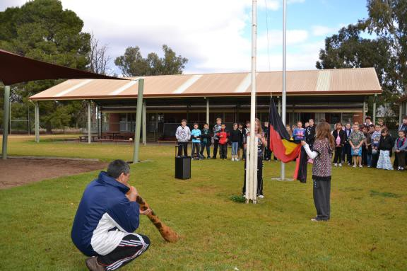Parents are welcome to seek a interview with their child’s teacher at any time which is mutually convenient for both parties. Interviews are often sought after student reports go home at the end of terms two and four but parents should feel free to arrange to see a teacher any time they see a need. The teaching staff and the Principal are always willing to discuss any concerns you may have about the school at mutually convenient times. The best place to discuss any problems or difficulties is at the school. It is often surprising how an exchange of views, based on full and correct information, can clear up misunderstandings or worries the parent or teacher may have. Please contact the school office for an appointment.
All belongings should be clearly and permanently marked with child’s name. If hats and jumpers are found, they are put in the lost property box which is kept in the office. If a name is on the property, it is returned to the child.
Whilst the teachers do their best to safeguard the property of the children, parents should be aware that it is possible for toys and special items that the children may bring to school to be mislaid, or go missing for other reasons.

MEDICAL AND STUDENT INFORMATION

An enrolment form and student information cards, as well as information stored on the School's computer, is kept on each child.
As this information is essential if the school needs to contact you or nominated caregivers, please notify us of any change to home or emergency contact numbers.

MEDICINES AT SCHOOL

If your child is on medication please try to arrange doses so that they are taken at home. Where the child is on some form of permanent medication you should discuss this with the Principal to find out the school policy.
If a child is undertaking a regular course of medication, an indemnity form must be completed and kept at the school. Please contact the office for further information.

MOBILE PHONES

Students are not permitted to have mobile phones on their person or to use mobile phones during school hours.

Several issues arise in regard to this matter.

- Inappropriate use of mobile phones e.g. nuisance calls or texting, bullying.
- Inappropriate use of phones during class time both for calls and use of games or cameras.
- Security of phones. As with other electronic games, etc., their security from theft or breakage can be an issue.

At Darlington Point students may only bring mobile phones to school if there is a need for them to be able to contact their parents either before arriving at school or in the afternoon after leaving school. If there is a need, as above, the child must bring a note from home on each day that the phone is required. Upon arrival at school the phone is to be checked in at the school office where it will be turned off and kept securely for the day. It is the child’s responsibility to collect the phone at the end of the day.

Parents with an urgent need to be in contact with their child during the day should contact the school office and appropriate steps will be taken to pass on the message or arrangements will be made for the child to return the call on the school phone.

If students are found to have a phone at school it will be confiscated and left at the school office for parents to collect.

MONEY AND VALUABLES

All money sent to school should be placed in an envelope, clearly marked with name and class and the purpose of the money. Money for canteen should be
in a purse or wallet with their name on it. Jewelry and earrings (apart from sleepers and studs) should not be worn to school because of the danger involved.
Special or expensive toys are to be left at home and no responsibility will be accepted if damaged at school.

NEWSLETTER

Our newsletter provides information concerning events of the week and school activities and is sent home weekly. They are distributed to the eldest student of each family on the first school day of each week.

NUT PRODUCTS

Some students who attend Darlington point Public School have severe allergies to nut products. We ask that you ensure that your child where possible does not bring nut products to school such as peanut butter sandwiches.
Students are also asked not to share their lunch and recess with other students.

Our canteen is a Nut Free Zone.

PARENT/CARER HELPERS

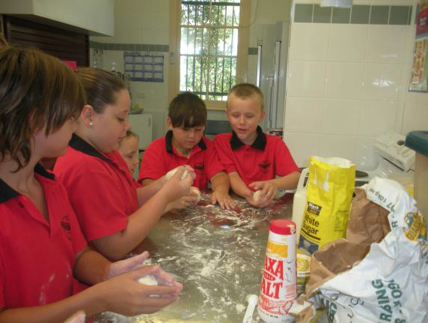Parent and community involvement with the school is essential in assisting children to learn. If you are able and interested in helping with activities at school or in classes, read the weekly newsletter or contact your child’s class teacher.

PARENTS & CITIZENS ASSOCIATION

P & C Association meetings are held on the third and eighth Wednesday of each term at 7.30pm in the library. The P&C helps to provide additional resources and equipment for the school as well as being vital communication links between the school and community.

PHOTOS

School photographs are taken each year as a keepsake of your child’s school years. Photographs are taken in Term 3 in winter uniform. Prepayment for photos is required by the photographers. Order forms and money envelopes are sent home prior to the photos being taken.

PLAYGROUND

The school playground routine is designed to allow children to play in safety and to allow everybody a ‘fair go’ with the facilities available. Separate playground equipment is provided for Infants and Primary students.

Pupils are directly supervised by rostered teachers from 9.00am until 3.25pm. Permission to leave the school grounds can only be given following a written request from a parent or guardian.

No direct supervision is rostered before 8:50am. Students who arrive early must wait quietly outside the gate.

PUPIL WELFARE

A high standard of socially acceptable behaviour is expected from every child. Children are also encouraged to practise self-discipline, accept responsibility and learn to respect and be tolerant with each other and the community.
If a child has to be disciplined they will be dealt with by their class teacher, or, if necessary, by the Principal. If a child persistently offends, the parents will be invited to our school to work together to
help the child.

READING RECOVERY

Reading Recovery is an early intervention program designed for Year 1 students, to reduce reading failure. The Reading Recovery program aims to accelerate student progress to the average level of their class as quickly as possible, by offering daily instructions of ½ hour in a range of literacy activities involving both reading and writing.

REPORTS

Darlington Point Public School student reports reflect changes made to the DET reporting policy implemented in 2006. Detailed, comprehensive assessment reports are sent home at the end of Semester 1 and Semester 2. These reports give an overall view of your child’s progress and development. The reports summarise strengths and weaknesses.

You will be able to see the progress of skills your child is attaining and also the outcomes that are being set for students at their level of schooling.

SCHOOL COUNSELLOR

Our school counsellor visits the school one day per fortnight. If you are experiencing difficulties or feeling concerned about the development and progress of your child an appointment can be made with the counsellor after discussion with your child's teacher.

SCHOOL TIMES

School commences each day, Monday to Friday, at 9.15am and concludes at 3.15pm.

The playground is supervised from 8:50am. Children should not arrive before this time.

SCHOOL UNIFORM

The wearing of a school uniform indicates pride in the school and shows other people that students are aware of their school achievements. The maintenance of a uniform is far cheaper than furnishing miscellaneous items.

Darlington Point uniforms are attractive and functional. A strong emphasis is placed on students wearing full school uniform at all times.

A sun awareness No Hat No Play policy operates throughout the school. Students are encouraged to wear a hat whilst outside.
All uniform supplies are sold, by the P&C at our school. Please see the school office for more details.

School Colours: Red and Black Sports Colours: Green and Yellow

Girl’s Uniform Summer:
Red T-Shirt with black collar and school emblem
Black shorts/skorts White socks
Black shoes/sneakers Hat

Winter:
Red T-Shirt/Long sleeved shirt with black collar and school emblem
Red Sloppy Joe with school emblem Black tracksuit pants/slacks
White socks
Black shoes/sneakers Hat

Sport:
Plain black sport skirt, skorts or bike shorts
T-shirt with house colours White socks
Sports shoes
Black tracksuit pants and school Sloppy Joe may be worn on cooler days with house colours underneath
Hat

Boy’s Uniform Summer:
Red T-shirt with black collar and school emblem
Black shorts White socks
Black shoes/sneakers Hat

Winter:
Red T-shirt/Long sleeved shirt with black collar and school emblem
Red Sloppy Joe with school emblem Black tracksuit pants/slacks
White socks
Black shoes/sneakers Hat

Sports:
Plain black shorts
- shirt with house colours White socks
Sports shoes
Black tracksuit pants and school sloppy joe may be worn on cooler days with house T-shirt underneath
Hat

Parents are requested to ensure that students do not wear pants with writing or coloured stripes on them to school.

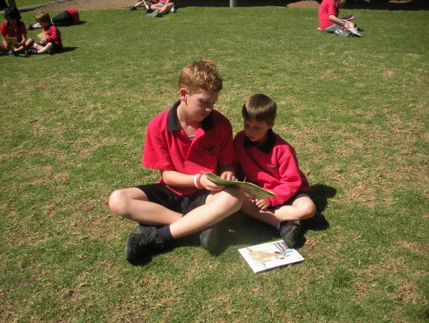It is essential that everything worn or brought to school be clearly labelled with each child’s name.

SCRIPTURE

Scripture is available for all students. Lessons are held every Friday.

If the school does not cater for your religious beliefs/ needs please contact the school and we will attempt to accommodate you.

SMOKING

Darlington Point Public School is a Smoke Free Zone.

SPECIAL DAYS

Many special days are observed throughout the year.

  - ANZAC Day
  - Education Week Open Day
  - Book Week
  - Naidoc Day
  - Kindergarten Orientation Days
  - Mufti Days for special causes
  - Special Sporting Days

Such days are advertised in the School Newsletter.

SPORT

A variety of sporting activities are included in our sports program on Friday afternoons. Each student is allocated to a House – Hawks (Green) or Eagles (Yellow).

Annual House Carnivals are conducted in Swimming, Athletics and Cross Country running. Successful students are given the opportunity of representing the school in P.S.S.A. sport at District, Region and State levels.

SUN PROTECTION

It is the policy of our school to actively support and encourage our children to wear a hat and sunscreen daily to protect them from the dangers of the sun.
Children not wearing hats will play in one of the shaded areas of the school.

TESTING

Assessment and evaluation are an integral part of our school program. These processes include ongoing assessments, weekly tests, general purpose tests and standardised tests.
NAPLAN (National Assessment Program Literacy and Numeracy) for students in Years 3 and 5 is administered in Term 2. External Australian Schools tests in English, Science, Maths and Computing administered by the University of NSW are conducted annually and participation is offered to students in Years 3 – 6.

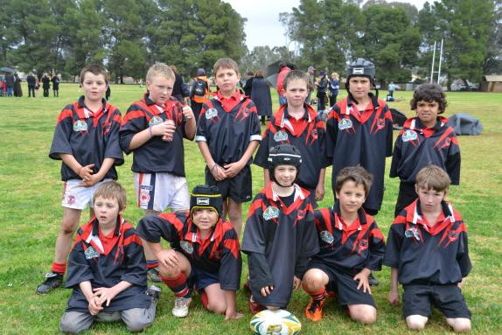

VISITORS IN AND AROUND THE SCHOOL

All parents and visitors need to come to the school office when they first enter the school to sign in before going to a classroom or into the playground. This is to ensure safety and protection of students and visitors, as we need to know who is on school grounds in case of an emergency.

VOLUNTARY CONTRIBUTIONS

To enable the school to purchase the resource necessary to give your children a full and relevant education, we ask each family to contribute towards the cost of these resources.

Contributions requested are: One Child - $30
Family - $50

School Song
Darlington Point lies along the riverside Set in the west where the nation’s future lies
Here the children come to learn to read and to write and to start along life’s road.

Through the rooms we are a passing As we grow in years and knowledge
But we always will remember many happy days spent here.

School Prayer

This is our school let peace dwell here.
Let the rooms be full of contentment And love abide here.

Love of God
Love of one another
And love of life itself.

Let us remember that many hands build a house So many hearts make a school

Tomorrow is ours.

National Anthem

Australians all let us rejoice, For we are young and free;
We’ve golden soil and wealth for toil; Our home is girt by sea;
Our land abounds in nature’s gifts Of beauty rich and rare;
In history’s page, let every stage Advance Australia Fair.
In joyful strains then let us sing, Advance Australia Fair.

Beneath our radiant Southern Cross We’ll toil with hearts and hands;
To make this Commonwealth of ours Renowned of all the lands;
For those who’ve come across the seas We’ve boundless plains to share; With courage let us all combine
To Advance Australia Fair.
In joyful strains then let us sing, Advance Australia Fair.

